**Southern River College**

**YEAR 12 PHYSICS, Evaluation and Analysis**

**RESPOND TO SCIENTIFIC ARTICLES ABOUT MODERN PHYSICS**

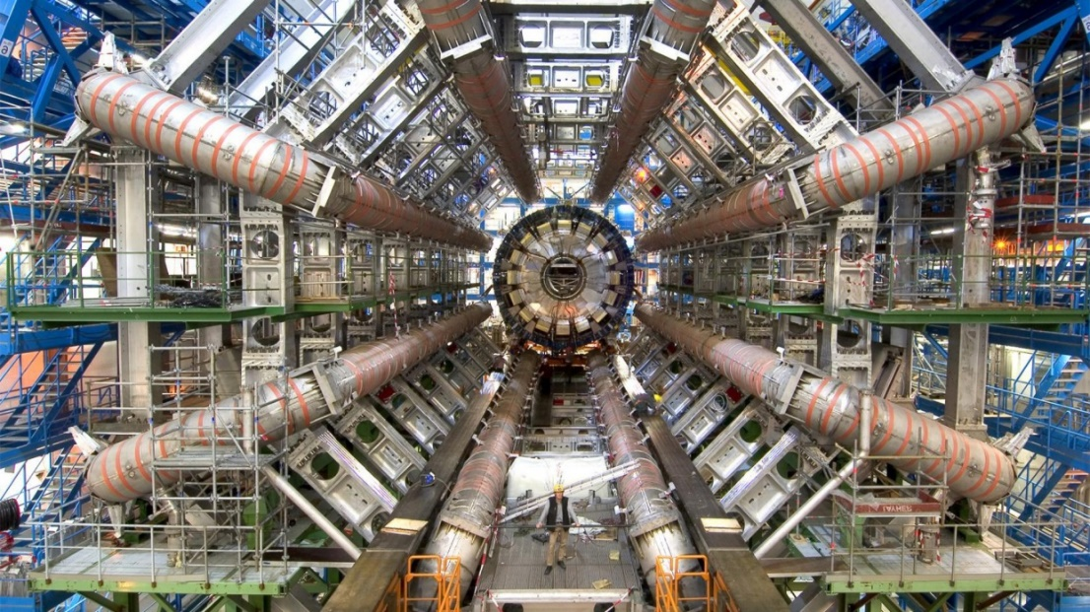

**Instructions**

*This package contains eight articles taken from various sources. Your task is to read and engage with the articles, ensuring that you understand and can explain the principles discussed. You may highlight or underline anything in these articles but you may not make notes on these pages. You are encouraged to research further and prepare a glossary of terms included in the articles and elsewhere in your reading.*

*The validation test will be held on* ***Friday, September 9.******You must bring these articles to the test.*** *You will not be permitted any other notes but you will be provided the usual formulae and data booklet.*

*The validation test will comprise questions which will assess your understanding of the articles combined with other knowledge of modern physics gained from the course (particle physics, special relativity, cosmology, particle accelerators, synchrotrons, etc.). There will be questions directly related to the article content and some indirectly related. Some of the data in the articles may be used to formulate questions which involve calculations.*

*The best preparation for the assessment is to read and research these articles thoroughly and to be up to date with all coursework. You should aim to understand the general principles and ideas presented in the articles, not necessarily every detail. Be wary of relying on copying text to answer questions. Past experience suggests that it is much more effective to have a general understanding of the articles which you can paraphrase and/or summarise as required.*

**Good luck!**

**Article 1: A step closer to solving one of the biggest mysteries in fundamental physics?**

**[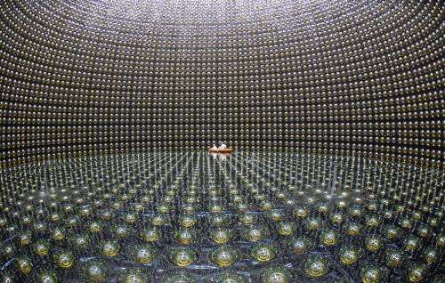](http://cdn.phys.org/newman/gfx/news/hires/2011/t2kph20.jpg)**

The T2K ‘water tank’ with its array of optical sensors

(PhysOrg.com) -- Where did all the matter in the universe come from? This is one of the biggest mysteries in fundamental physics and exciting results released on 15 June 2011 from the international T2K neutrino experiment in Japan could be an important step towards resolving this puzzle.

The intriguing results indicate a new property of the enigmatic [particles](http://www.physorg.com/tags/particles/) known as [neutrinos](http://www.physorg.com/tags/neutrinos/).

There are three types of neutrinos (called flavours) - one paired by particle interactions with the familiar electron (called the electron neutrino), and two more paired with the electron's heavier cousins, the muon and tau leptons. Previous experiments around the world have shown that these different flavours of neutrinos can spontaneously change into each other, a [phenomenon](http://www.physorg.com/tags/phenomenon/) called 'neutrino oscillation'.

Two types of oscillations have already been observed but in its first full period of operation, the T2K experiment has already seen evidence for a new type of oscillation (the appearance of electron neutrinos in a muon neutrino beam). This means that we have now observed that neutrinos can oscillate in every way possible.

This level of complexity opens the possibility that the oscillations of neutrinos and their anti-particles (called anti-neutrinos) could be different. And if the oscillations of neutrinos and anti-neutrinos are different, it would be an example of what [physicists](http://www.physorg.com/tags/physicists/) call CP violation. This could be the key to explaining why there is more matter than [anti-matter](http://www.physorg.com/tags/anti+matter/) in the universe (an excess which could not happen within the known [laws of physics](http://www.physorg.com/tags/laws+of+physics/)).

The experiment ran from January 2010 until 11 March 2011, when it was dramatically interrupted by the Japanese earthquake. Fortunately, the multinational T2K team were unharmed and their highly sensitive detectors were largely undamaged. Six clean electron neutrino events were observed in the data from before the earthquake, while in the absence of oscillations there should only have been between 1 or 2. Even though such an excess could only happen by chance about one time in a hundred, that is not good enough to confirm a new physics discovery, so this is called an 'indication'.

Prof Dave Wark of STFC and Imperial College London, who served for four years as the International Co-Spokesperson of the experiment and is head of the UK group, explains, "People sometimes think that scientific discoveries are like light switches that click from 'off' to 'on', but in reality, it goes from 'maybe' to 'probably' to 'almost certainly' as you get more data. Right now, we are somewhere between 'probably' and 'almost certainly'."  
  
Read more at: <http://phys.org/news/2011-06-closer-biggest-mysteries-fundamental-physics.html#jCp>

Prof Christos Touramanis from Liverpool University is the Project Manager for the UK contributions to T2K: "We have examined the near detectors and turned some of them back on, and everything that we have tried works pretty well. So far it looks like our earthquake engineering was good enough, but we never wanted to see it tested so thoroughly."

Prof Takashi Kobayashi of the KEK Laboratory in Japan and spokesperson for the T2K experiment, said "It shows the power of our experimental design that with only 2% of our design data we are already the most sensitive experiment in the world for looking for this new type of oscillation."

**About T2K**

The experiment is a huge undertaking with over 500 scientists from 12 countries. The UK has invested £14.3M in the T2K project.

There are three elements to the experiment:

• A beam of muon neutrinos is produced at the Japan Proton Accelerator Research Center in Tokai, Japan. Engineers from the UK’s Rutherford Appleton Laboratory helped in the design, production, and testing of a number of the elements of this neutrino production system.

• The neutrinos then pass through a [complex](http://www.physorg.com/tags/complex/) set of near detectors located 280 meters from the target in order to determine the neutrino beam's composition and properties before the neutrinos have a chance to oscillate.

• The neutrinos then fly under the ground for 295 km across Japan to the mammoth Super Kamiokande neutrino detector (a tank of 50,000 tons of ultra-pure water surrounded by sensitive optical detectors which can see the very faint flashes of light emitted by the very rare interactions of passing neutrinos with the water). This is capable of telling muon neutrinos from electron neutrinos with high precision, and is thus ideal for looking for the appearance of a small fraction of electron neutrinos appearing in the muon neutrino beam, the key signature of this new type of oscillation.

**Article 2: Evidence mounts that neutrinos are the key to the universe's existence**

August 8, 2016 by Hayley Dunning

**[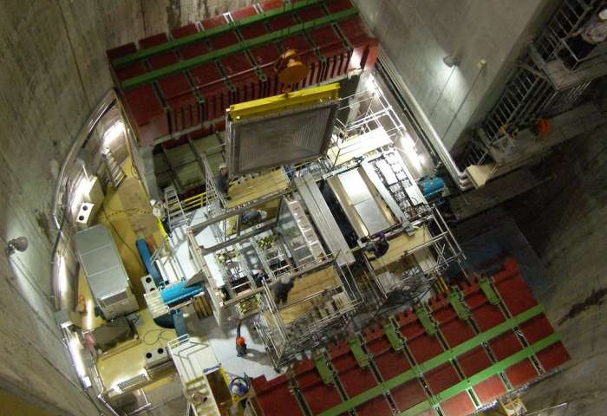](http://cdn.phys.org/newman/gfx/news/2016/57a86fd484929.jpg)**

The T2K near detector. Credit: Imperial College London

New experimental results show a difference in the way neutrinos and antineutrinos behave, which could explain why matter persists over antimatter.

The results, from the T2K experiment in Japan, show that the degree to which [neutrinos](http://phys.org/tags/neutrinos/) change their type differs from their antineutrino counterparts. This is important because if all types of matter and antimatter behave the same way, they should have obliterated each other shortly after the Big Bang.

So far, when scientists have looked at matter-antimatter pairs of particles, no differences have been large enough to explain why the universe is made up of matter – and exists – rather than being annihilated by antimatter.

Neutrinos and antineutrinos are one of the last matter-antimatter pairs to be investigated since they are difficult to produce and measure, but their strange behaviour hints that they could be the key to the mystery.

**Flavour change**

Neutrinos (and antineutrinos) come in three 'flavours' of tau, muon and electron, each of which can spontaneously change into the other as the neutrinos travel over long distances.

The latest results, announced today by a team of researchers including physicists from Imperial College London, show more [muon neutrinos](http://phys.org/tags/muon+neutrinos/) changing into electron neutrinos than muon antineutrinos changing into electron antineutrinos.

This difference in muon-to-electron changing behaviour between neutrinos and antineutrinos means they would have different properties, which could have prevented them from destroying each other and allow the universe to exist.

To explore the (anti)neutrino flavour changes, known as oscillations, the T2K experiment fires a beam of (anti)neutrinos from the J-PARC laboratory at Tokai Village on the eastern coast of Japan.

It then detects them at the Super-Kamiokande detector, 295 km away in the mountains of the north-western part of the country. Here, the scientists look to see if the (anti)neutrinos at the end of the beam matched those emitted at the start.

**Very intriguing**

The latest results were concluded from relatively few data points, meaning there is still a one in 20 chance that the results are due to random chance, rather than a true difference in behaviour. However, the result is still exciting for the scientists involved.

Dr Morgan Wascko, international co-spokesperson for the T2K experiment from the Department of Physics at Imperial said: "This is an important first step towards potentially solving one of the biggest mysteries in science.

"T2K is the first experiment that is able to study neutrino and antineutrino oscillation under the same conditions, and the disparity we have observed is, while not yet statistically significant, very intriguing."

Dr Yoshi Uchida, also from the Department of Physics at Imperial and a principal investigator at T2K, added: "More data is needed to prove conclusively that neutrinos and antineutrinos behave differently, but this result is an indication that neutrinos will continue to provide breakthroughs in our understanding of the universe.

Upgrades to the equipment that produces (anti)neutrinos, as well as to the detector that measures them, are expected to add more data within the next decade, and determine whether the difference is in fact real.

Read more at: <http://phys.org/news/2016-08-evidence-mounts-neutrinos-key-universe.html#jCp>

**Article 3: The Universe Is Expanding Even Faster Than Believed**

June 5th 2016 07:54 AM

Bottom of Form

Astronomers have used Hubble to measure the distances to stars in nineteen galaxies more accurately than previously possible. They found that the Universe is currently expanding faster than the rate derived from measurements of the Universe shortly after the Big Bang. If confirmed, this apparent inconsistency may be an important clue to understanding three of the Universe's most elusive components: dark matter, dark energy and neutrinos.

A team of astronomers [have discovered that the Universe is expanding between five and nine percent faster than previously calculated](http://hubblesite.org/pubinfo/pdf/2016/17/pdf.pdf). This is in clear discrepancy with the rate predicted from measurements of the infant Universe. One possible explanation for this unexpectedly fast expansion of the Universe is a new type of subatomic particle that may have changed the balance of energy in the early Universe, so called dark radiation.

The team made the discovery by refining the measurement of how fast the Universe is expanding, a value called the Hubble constant, to unprecedented accuracy, reducing the uncertainty to only 2.4 percent.

This new measurement presents a puzzle because it does not agree with the expansion rate found by looking at the moments shortly after the Big Bang. Measurements of the afterglow from the Big Bang from NASA's Wilkinson Microwave Anisotropy Probe (WMAP)and the European Space Agency's Planck satellite mission yield smaller predictions for the Hubble constant.

This illustration (following page) shows the three steps astronomers used to measure the universe's expansion rate to an unprecedented accuracy, reducing the total uncertainty to 2.4 percent. Astronomers made the measurements by streamlining and strengthening the construction of the cosmic distance ladder, which is used to measure accurate distances to galaxies near and far from Earth. Beginning at left, astronomers use Hubble to measure the distances to a class of pulsating stars called Cepheid variables, employing a basic tool of geometry called parallax. This is the same technique that surveyors use to measure distances on Earth. Once astronomers calibrate the Cepheids' true brightness, they can use them as cosmic yardsticks to measure distances to galaxies much farther away than they can with the parallax technique. The rate at which Cepheids pulsate provides an additional fine-tuning to the true brightness, with slower pulses for brighter Cepheids. The astronomers compare the calibrated true brightness values with the stars' apparent brightness, as seen from Earth, to determine accurate distances. Once the Cepheids are calibrated, astronomers move beyond our Milky Way to nearby galaxies (shown at center). They look for galaxies that contain Cepheid stars and another reliable yardstick, Type Ia supernovae, exploding stars that flare with the same amount of brightness. The astronomers use the Cepheids to measure the true brightness of the supernovae in each host galaxy. From these measurements, the astronomers determine the galaxies' distances. They then look for supernovae in galaxies located even farther away from Earth. Unlike Cepheids, Type Ia supernovae are brilliant enough to be seen from relatively longer distances. The astronomers compare the true and apparent brightness of distant supernovae to measure out to the distance where the expansion of the universe can be seen (shown at right). They compare those distance measurements with how the light from the supernovae is stretched to longer wavelengths by the expansion of space. They use these two values to calculate how fast the universe expands with time, called the Hubble constant.

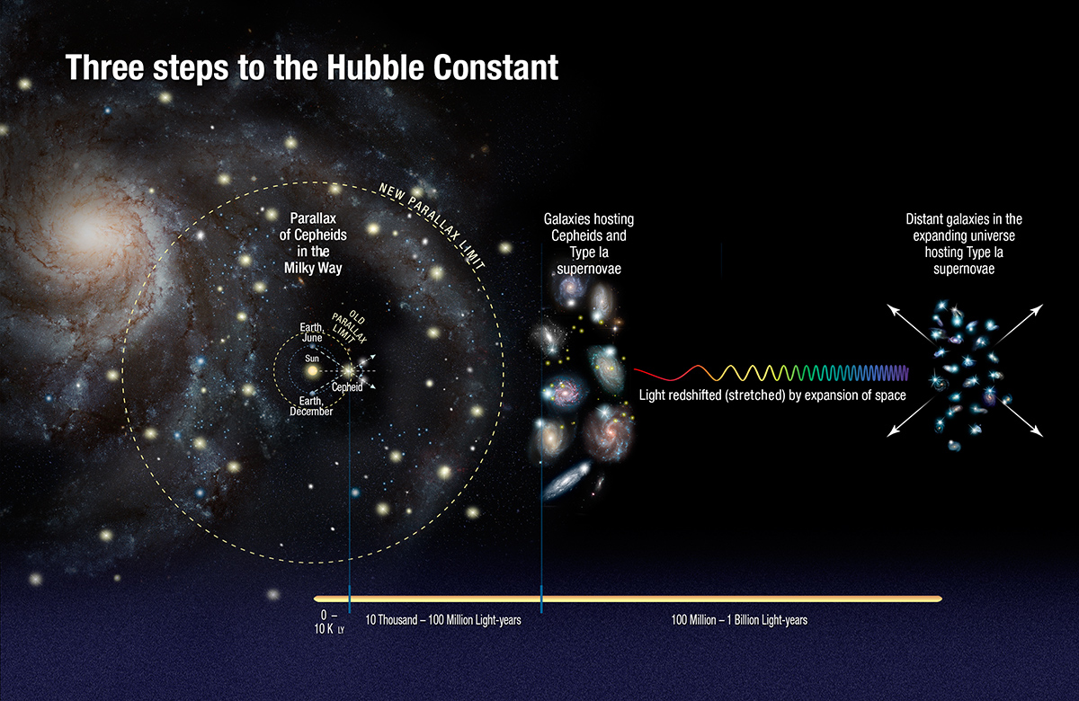

"This surprising finding may be an important clue to understanding those mysterious parts of the Universe that make up 95 percent of everything and don't emit light, such as dark energy, dark matter, and dark radiation," explains Nobel Laureate Adam Riess of the Space Telescope Science Institute and the Johns Hopkins University.

Comparing the Universe's expansion rate as calculated by WMAP and Planck (for the time after the Big Bang) and Hubble (for our modern Universe) is like building a bridge, Riess explains: "You start at two ends, and you expect to meet in the middle if all of your drawings are right and your measurements are right. But now the ends are not quite meeting in the middle and we want to know why."

This refined determination of the Hubble constant was made possible by making precise measurements of the distances to both nearby and faraway galaxies using Hubble [2]. The improved distance measurements were made by streamlining and strengthening the cosmic distance ladder, which astronomers use to measure accurate distances to galaxies. The team compared these measured distances with the expansion of space as measured by the stretching of light from receding galaxies and these two values were then used to calculate the Hubble constant.

[COSMOS CONVERSATION](https://cosmosmagazine.com/sections/cosmos-conversation) [PHYSICS](https://cosmosmagazine.com/topics/physics) 26 JULY 2016

Article 4: From dark gravity to phantom energy: what’s driving the expansion of the universe?

There is something strange happening in the local universe, with galaxies moving away from each other faster than expected. What is driving this extra expansion, and what does it mean for the cosmos?

**There is something strange happening in the local universe**, with galaxies moving away from each other [faster than expected](http://www.science20.com/news_articles/the_universe_is_expanding_even_faster_than_believed-173999).

What is driving this extra expansion, and what does it mean for the cosmos? To explore this, let’s start with the observations.

[The dark side of the universe – a primer](https://cosmosmagazine.com/physics/the-dark-side-of-the-universe-a-primer)

The rate of cosmic expansion is encapsulated in the “[Hubble constant](http://hyperphysics.phy-astr.gsu.edu/hbase/astro/hubble.html)”, although don’t let the name fool you, as it’s not a constant and changes as the universe expands. To determine this constant, astronomers must relate the distances to galaxies to the velocity they’re travelling away from us. But measuring astronomical distances has always proven difficult. This is because we lack convenient signposts, known as [standard candles](http://hyperphysics.phy-astr.gsu.edu/hbase/astro/stdcand.html) and [rulers](http://philosophy-of-cosmology.ox.ac.uk/standard-rulers.html), to chart the heavens.

So, astronomers have built up cosmic distances through a series of steps, using overlapping methods to span the heavens. But each step in this [cosmological distance ladder](https://terrytao.files.wordpress.com/2010/10/cosmic-distance-ladder.pdf) has its own quirks and uncertainties, and extraordinary effort over many decades has been expended to calibrate the various methods.

A new [paper](https://arxiv.org/pdf/1604.01424.pdf) has pushed this calibration even harder, using a number of methods to tie down the Hubble constant to an accuracy of 2.4% within a few hundred million light years (which is local by cosmic standards).

A great success! But there’s a problem.

We can also determine the universal expansion from observations of the [cosmic microwave background](http://astronomy.swin.edu.au/cosmos/C/Cosmic+Microwave+Background), which is the radiation leftover from the [Big Bang](http://www.universetoday.com/54756/what-is-the-big-bang-theory/).

Unlike local observations, this reveals the global, large-scale expansion of the universe. And this is where the problems begin, as this global expansion is 9% slower than that seen in the local universe. In both measurements, the astronomers have worked hard to reduce the uncertainties, and so are confident this difference is valid.

So, what can explain this tension in cosmic measurement? Here are a few of the contenders.

Cosmic contenders

Dark matter

The first potential culprit is [dark matter](http://www.space.com/20930-dark-matter.html), the dominant *mass* in the universe. We know it is not smoothly spread through space, so perhaps the lumps and bumps, like the galaxies and clusters of galaxies, are exacting less gravitational pull in the local universe.

[Dark matter uncovered](https://cosmosmagazine.com/space/dark-matter-uncovered)

Perhaps we are in a [cosmic void](http://www.universetoday.com/15719/the-cosmic-void-could-we-be-in-the-middle-of-it/), a region whose density is below the universal average.

If this were the case, we would have to be inhabiting a strange corner of the universe, sitting at the centre of immense emptiness not very unlike anything expected in our [cosmological ideas](http://astronomy.swin.edu.au/cosmos/L/large-scale+structure).

Dark energy

And then there is [dark energy](http://hetdex.org/dark_energy/dark_matter.php), most likely the dominant *energy* in the universe. This component is thought responsible for accelerating the cosmic expansion, but is assumed to have a very simple form, eternal and unchanging over all of history.

But what if dark energy is dynamic and evolving, changing its properties as the universe expands? If it changed quite recently (in cosmic terms), the additional expansion could be imprinted on the local universe, but have not yet impacted the global expansion.

If this is the case, the universe has something to worry about, as this new form of dark energy would be a “[phantom](https://www.physics.rutgers.edu/~saurabh/690/Mar27-Zhang-phantom.pdf)”, driving universal expansion faster and faster into a “[big rip](http://www.telegraph.co.uk/news/science/science-news/11715091/Big-Rip-will-end-the-universe-scientists-claim.html)”, which is more dramatic than it sounds.

Dark radiation

Another potential solution is “dark radiation”, which consists of hyper-fast particles that zipped around in the early universe.

While there is no single definition on what constitutes dark radiation, a favoured candidate is a new member of the [neutrino family](http://www.ps.uci.edu/~superk/neutrino.html), affectionately known as [sterile neutrinos](http://www.quantumdiaries.org/2014/07/27/sterile-neutrinos/).

While dark radiation is theoretical, there is little observational evidence for its existence. But if it had been present in the early universe, it would have influenced the early expansion of the universe, which would still be imprinted on the global value of the Hubble constant, but would now be washed out of the local value.

[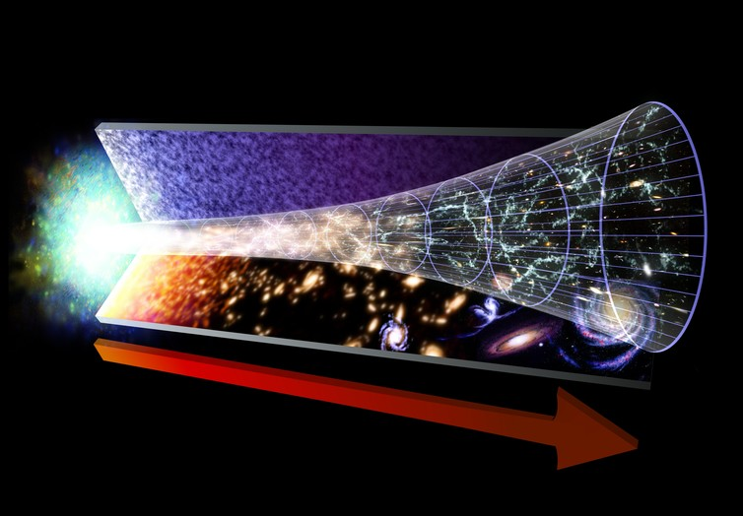](https://62e528761d0685343e1c-f3d1b99a743ffa4142d9d7f1978d9686.ssl.cf2.rackcdn.com/files/125320/area14mp/image-20160606-25985-3ass74.jpg)

A diagram representing the evolution of the universe, starting with the Big Bang to present day. The red arrow marks the flow of time. New research suggests it’s expanding even faster than shown here. NASA/GSFC

Dark gravity

The potential solutions so far have considered modifying the properties of components in the universe, but there is the more drastic alternative: [dark gravity](http://arxiv.org/abs/0711.0077).

This suggests that we don’t fully understand the fundamental nature of the universe, and that gravity does not follow the rules laid out by [Albert Einstein](http://www.nobelprize.org/nobel_prizes/physics/laureates/1921/einstein-bio.html) in his [general theory of relativity](https://www.newscientist.com/round-up/instant-expert-general-relativity/).

Such theories of [modified gravity](http://arxiv.org/pdf/1106.2476v3.pdf) have existed for a long time, and come in many forms, and it is not clear how we deduce the impact of such gravity on the universal expansion.

Dark speculations

So, there are several alternatives that could potentially explain the discrepancy between the local and global measurements of the Hubble constant. Which one is correct?

At the moment, the observations are rather raw and do not discriminate between the possibilities. And so, we enter the realm of theoretical speculation, where ideas are tried and discarded until viable explanations are discovered.

[The problem with dark matter](https://cosmosmagazine.com/physics/problem-dark-matter)

At the same time, astronomers will seek more data, and will continue to tie down calibrations and methods. This brings us to our final possibility.

No observations are perfect, and much of science is about understanding the uncertainties of measurements. Scientists can generally wrangle [random errors](https://explorable.com/random-error) and understand how uncertainties in measurement impact uncertainties in results.

But there is another uncertainty: the [systematic error](http://www.physics.umd.edu/courses/Phys276/Hill/Information/Notes/ErrorAnalysis.html), which can strike fear into a researcher. Instead of scattering results, systematic errors shift all results one way or another.

Systematic errors can also influence astronomical distance measures. And if they propagate through the distance ladder, they could potentially shift the local measurement of the Hubble constant away from the global value.

With new data and methods, this tension may evaporate. Some astronomers are already suggesting that this is a [“more reasonable explanation”](https://arxiv.org/pdf/1606.00634.pdf).

**ARTICLE 5**

**The Australian Synchrotron is great … but what does it do?**

March 23, 2012

**By Andrew Peel and Nancy Mills**

Science is like high-performance racing: today’s Formula One machine is all too soon the jalopy of tomorrow. The Australian Synchrotron, opened in 2007 and located in Melbourne, is currently at the F1 end of the spectrum. Needless to say, its 120 staff and thousands of active researchers would like to keep it that way.

Which raises a pertinent and obvious question: what does it actually do?

Technically speaking, a synchrotron is [a large machine](http://www.synchrotron.org.au/index.php/synchrotron-science/what-is-a-synchrotron) that accelerates electrons to almost the speed of light. As those electrons are deflected through magnetic fields they create extremely bright light, meaning a synchrotron is also a “light source”. Synchrotron light (X-rays and infrared light) is a million times brighter than the sun.

Compared to conventional sources, such as those that might be encountered while sitting in a dentist’s chair, the X-rays produced at the Synchrotron are like a laser is to a light bulb.

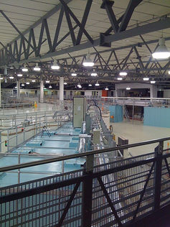In addition to their high brightness, X-rays are emitted as a beam and can be effectively tuned to a single wavelength (a bit like being able to choose the colour of your laser beam). Along with other, more specialised properties, such as nanosecond-scale pulsed emission, the characteristics of the light means synchrotron-based experiments are typically more accurate, more detailed, more specific and faster than those obtained using conventional laboratory equipment.

To the thousands of researchers who use it each year, the facility is a toolbox of state-of-the-art experimental techniques that enables them to reach their research goals faster and to go beyond what they could otherwise achieve in a conventional laboratory.

The football field-sized facility – with 10 purpose-built individual experimental laboratories – offers access to the nanoscale world by several different paths.

Since the facility opened, more than 4,000 biologists, medical scientists, chemists, materials scientists, forensic scientists, geo-chemists, physicists, engineers, art conservators, environmental scientists and agricultural scientists, among others, have taken advantage of the new approaches available to them.

*Inside the synchrotron*

For most researchers, it’s a place to conduct experiments that simply could not be performed anywhere else in the country.

**The need for speed**

The brightness of synchrotron X-rays means that determining the three-dimensional structure of an AIDS virus protein – to give just one example – could take a matter of minutes instead of hours, or even days, of data collection and manipulation. This technique relies on making crystals of the target protein that are of a certain quality.

The Synchrotron can rapidly screen many thousands of “candidate” crystals, with usable data collected in hours, rather than months as might be required with conventional approaches.

[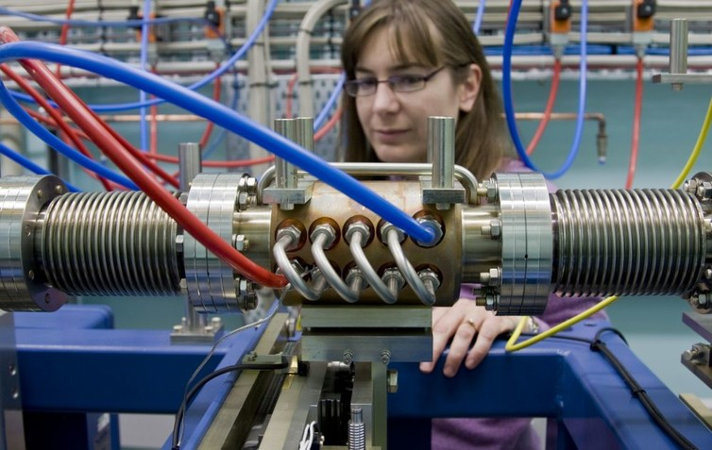](https://62e528761d0685343e1c-f3d1b99a743ffa4142d9d7f1978d9686.ssl.cf2.rackcdn.com/files/8835/area14mp/xpmkb777-1332302301.jpg)

*Synchrotron light is filtered and conditioned for use in determining protein structures. Sandra Morrow*

Many researchers view the Synchrotron as an essential tool for studying or developing new drugs to combat diseases such as various cancers, malaria, rheumatic fever and yellow fever.

Being able to determine highly-detailed three-dimensional structures of target proteins, either by themselves or interacting with potential drug molecules, speeds up the lengthy process of taking a drug from concept stage to the market.

Synchrotron techniques for determining protein structures are also helping researchers find new ways of tackling the malaria parasite, and expanding our knowledge of how the immune system works, which could lead to new treatments for autoimmune diseases such as [early onset diabetes](http://diabetes.ygoy.com/2009/07/13/early-onset-diabetes/) or for tissue rejection following bone marrow transplantation.

**A giant microscope?**

Other researchers see the facility as akin to a giant microscope that uses infrared light or X-rays to map the micro- or even nanoscale distribution of metals in mineral ores, or the location of proteins and fats in animal cells.

But, unlike a conventional light microscope, the Synchrotron can also identify the specific chemical form of the metals or other components under investigation – at each location on the map.

This is crucial information for those seeking to improve mineral prospecting or processing methods, or to understand the very early stage progression of diseases such as [multiple sclerosis](http://www.healthinsite.gov.au/topics/Multiple_Sclerosis) or [Parkinson’s](http://www.parkinsons.org.au/about-ps/whatps.html).

Heavyweight ([teraflop](http://kb.iu.edu/data/apeq.html)) computing power means that two-dimensional X-ray maps can also be transformed into three dimensions, much like a CT or [CAT scan](http://www.medicinenet.com/cat_scan/article.htm). The largely non-destructive nature of synchrotron techniques also makes them eminently suitable for examining precious cultural artefacts, artworks and documents, and for forensic investigations – particularly in instances where samples are only available in minute quantities.

**Going with the grain**

Rice, barley and other cereal grains are important energy sources for many millions of people around the world. Unfortunately, diets that rely too heavily on these relatively poor sources of nutrition are often low in important micronutrients such as iron.

Researchers from the University of South Australia, the Australian Centre for Functional Plant Genomics and the University of Melbourne are using synchrotron mapping techniques to investigate various strategies to improve the levels of iron, zinc and other important micronutrients in these staple food grains. Their findings, it is hoped, will aid the development of better processing methods and breeding programs.

[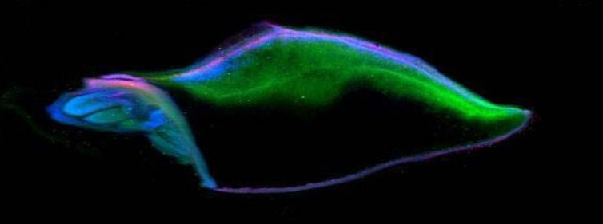](https://62e528761d0685343e1c-f3d1b99a743ffa4142d9d7f1978d9686.ssl.cf2.rackcdn.com/files/8836/area14mp/dr7zz9bb-1332302495.jpg) [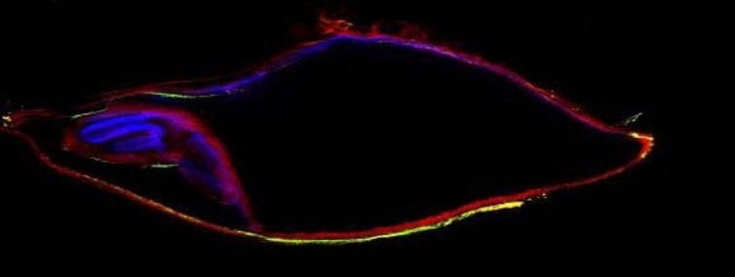](https://62e528761d0685343e1c-f3d1b99a743ffa4142d9d7f1978d9686.ssl.cf2.rackcdn.com/files/8837/area14mp/hrn547qh-1332302557.jpg)

*Top to bottom: tri-colour maps of: iron (red), copper (green) and zinc (blue); and potassium (red), calcium (green) and manganese (blue) distribution in a barley grain. Both images: Enzo Lombi*

Looking to the future, it’s possible to draw on the experience of [other synchrotron facilities](http://www.lightsources.org/cms/?pid=1000098) around the world and predict that the scale of impact and productivity of the Australian Synchrotron will grow. But this will only occur if two things happen:

1) The current operating capability of the facility is maintained. It was built by the Victorian Government, which invested A$157 million in the project. The Australian and New Zealand governments as well as universities and major research institutions such as ANSTO and CSIRO provided additional financial support worth A$50 million in total.

Currently, the Victorian and Australian Governments contribute equally to the operating costs.

2) The facility continues to operate at the cutting edge of synchrotron technology. The Synchrotron is very productive precisely because it operates at a level that allows the best techniques to be effectively deployed.

It is the ability to operate at this level, combined with the development of new and improved capabilities, that will enable the Australian synchrotron science community to achieve its full potential.

The Synchrotron is a powerhouse of Australian research. Keeping it at or above world standards is not just desirable – it’s essential.

**ARTICLE 6**

**How does the Australian Synchrotron work?**

*(Article from http://www.synchrotron.org.au/)*

The information in this section is intended for people who already have some knowledge of physics. Less-technical information about how synchrotrons work and what they do is available in the 'ABOUT SYNCHROTRONS' section.

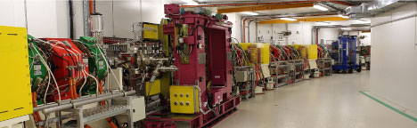

*Inside the Australian Synchrotron storage ring, where bunches of electrons travel at close to the speed of light*

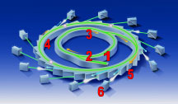

1. Electrons are produced at the electron gun by thermionic emission from a heated tungsten matrix cathode. The emitted electrons are then accelerated to an energy of 90 keV (kilo electron volts) by a 90-kilovolt potential difference applied across the gun, and move into the linear accelerator.

2. The linear accelerator (or linac) accelerates the electron beam to an energy of 100 MeV (mega electron volts) over a distance of about 10 metres.

3. The booster is an electron synchrotron 130 metres in circumference that takes the 100 MeV beam from the linac and increases its energy to 3 GeV (giga electron volts). The booster ring contains 60 combined function (steering and focussing) electromagnets to keep the electrons inside the stainless-steel vacuum chamber and a single 5-cell RF cavity (operating at 500 MHz) to supply energy for acceleration. The beam is accelerated by a simultaneous ramping of magnet strength and cavity fields. Each ramping cycle takes approximately one second for a complete ramp up and down. An electron spends about half a second in the booster ring and completes over one million laps.

4. The storage ring is the final destination for the accelerated electrons. It can hold 200 mA of stored current with a beam lifetime of over 20 hours. The storage ring is 216 metres in circumference and consists of 14 nearly identical sectors. Each sector consists of a 4.4 metre straight section and an 11-metre arc. Every arc contains two dipole ‘bending’ magnets where synchrotron light will be produced. Most of the straight sections have room for an ‘insertion device’.

5. Individual beamlines are positioned to capture the synchrotron light given off by the storage ring.   
The first section of every beamline is the photon delivery system (also called the ‘beamline optics’). It incorporates filters, monochromators, mirrors, attenuators and other devices to focus and select appropriate wavelengths for particular research techniques.

6. Experiments employing synchrotron light are conducted in customised facilities called end-stations. Most of the end-stations are housed inside radiation shielding enclosures called ‘hutches’ to protect staff and visitors from potentially harmful x-rays. Each beamline utilises the synchrotron light to gather data in the form of images, chemical spectra, and/or scattered light. Because research scientists cannot enter the hutches during data collection, much of the equipment is controlled remotely via motors and robotic devices.

**Features**

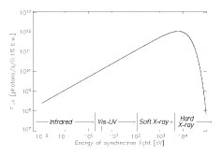The Australian Synchrotron is an advanced third-generation design. The magnet arrangement in the storage ring has been carefully designed to produce a high quality, low emittance, stable electron beam – and generate synchrotron light of high brilliance.

Light from bending magnets, multipole wigglers and undulators enables a wide range of advanced experiments or measurements to be carried out. Each of the 28 dipole magnets is a source of synchrotron light and most straight sections can host an insertion device – giving the possibility of over 30 beamlines at the Australian Synchrotron.

In addition to the two dipole bending magnets in each sector, there are dozens of quadrupole and sextupole magnets, in the storage ring. These serve mainly to keep the electron beam focused. An array of 98 beam monitors around the ring allows for extremely accurate measurements of the beam position. The electron beam is focussed, on average, to a path of just 60 micrometres wide.

An electron energy of 3 GeV was chosen for the Australian Synchrotron storage ring to allow for the production of light at frequencies that encompass a wide range of the electromagnetic spectrum, from far infra-red to hard x-rays.

During its time in the storage ring, the electron beam will gradually decay away as individual electrons scatter off residual gas molecules and each other. To minimise these losses, the beam circulates inside a stainless steel, ultra-high vacuum chamber, at a pressure of around 10-10 millibars (roughly equivalent to the moon’s atmosphere). However, there are still losses and the beam needs to be topped-up once or twice a day. Because beam losses cause the machine to emit radiation (high energy electrons colliding with matter create showers of radiation called bremsstrahlung), the machine is enclosed in radiation shielding walls consisting of concrete and lead to protect staff and users.

Low-conductivity water (similar to deionised water) cools the magnet coils without causing an electrical short circuit. To reduce the effects of thermal drift, the entire building and tunnel temperature are regulated to within 1 and 0.5 degrees Celsius respectively.

**Article 7: Edwin Hubble & the Expanding Universe**

**From Australia Telescope National Facility**

Edwin Hubble (1889 - 1953)



Credit: [*Emilio Segre Visual Archives*](http://www.aip.org/history/esva/)

Edwin Hubble at the camera on the Hooker 100-inch telescope on Mt Wilson.

Trained initially as a lawyer, Edwin Hubble moved to astronomy in 1914, working at the famous [Yerkes Observatory](http://astro.uchicago.edu/yerkes/) near Chicago. He went on to have a profound influence on our understanding of the Universe. Using the largest telescope of his time, the 100-inch Hooker telescope on [Mount Wilson](http://www.mtwilson.edu/) in California, he helped resolve one of the great debates in early twentieth century astronomy.

Island Universes

One of the unsolved problems in early twentieth century astronomy was the question of what were nebulae? These gaseous, fuzzy clouds were thought by some astronomers to be embryonic solar systems forming while others thought that they were "island universe" like our own Milky Way galaxy. The advent of spectroscopy and photography in that late nineteenth century when used on the latest generation of large reflecting telescopes in the early twentieth century provided astronomers with the tools to study these objects.

Hubble used the 100-inch Hooker Telescope on Mount Wilson, then the largest telescope in the world, to study the Andromeda Nebula, M 31. In 1923 he identified some of the stars within it as *Cepheid* variables. These are periodic variable stars, that is stars that vary their brightness in a regular way. Earlier, in 1908 **Henrietta Swan Leavitt**, working at the Harvard College Observatory discovered that Cepheid variables in fact obey a period-luminosity relationship; the longer the period of a Cepheid, the more intrinsically luminous it is. This allowed Hubble to observe the Cepheids over time and measure their varying brightness’s to determine their periods. He could then apply the period-luminosity relationship to calculate the distance to the stars and hence the distance to the Andromeda Nebula that they were in. By 1924 Hubble had calculated that the distance to the Andromeda Nebula was 900,000 light years.

Supporting evidence came from the work of **Vesto Sliphe**r at the Lowell Observatory in Arizona. He had started measuring the *Doppler shift* of spectral lines from spiral nebulae in 1912. By 1925 he had shown that most exhibited redshifts in their spectral lines. He interpreted this as meaning that they were in fact moving away relative to us so their spectrum was shifted to longer (i.e., *redder*) wavelengths). Whilst he calculated that the Andromeda spiral was moving towards us at 300 km.s-1 he soon found others moving away at 1,100 km.s-1. These speeds exceeded that of any known star in the Milky Way.

Taken together the evidence eventually convinced astronomers that "spiral "nebulae" such as Andromeda were in fact separate "island universes" of billions of stars like our own Milky Way but more distant. We now call these *galaxies* instead of island universes.

The Expanding Universe & Hubble's law

Hubble, aided by **Milton Humason** extended the work of Slipher by using the larger Hooker telescope. He took long exposures of the spectra of faint galaxies. By measuring the amount of shift of specific spectral lines relative to those produced by reference arc lamps in the spectrograph he was able to calculate values for the galaxy velocities. A few nearby galaxies had velocities that meant they were moving towards our own Milky Way, that is their lines were blueshifted but most exhibited redshift and hence had *recession velocities*. The majority of galaxies therefore appeared to be moving away from our own galaxy. Hubble found that that those with a smaller image in a photograph had higher redshifts. This is shown in the diagram below that shows the images and spectra of some of the galaxies he observed.

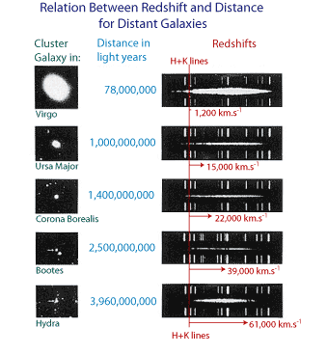

Hubble's observations of galaxies with the redshift in their spectral lines.

He inferred that galaxies were similar to each other in size so those that appeared smaller must be further away. By plotting the velocity of the galaxies against their distance he came across an interesting relationship. This is now known as Hubble's law and is shown in the following plot.

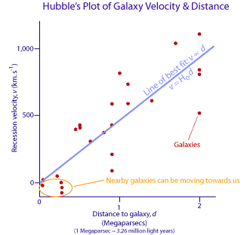

Hubble's distance-velocity relationship for galaxies based on his original data. This is now known as *Hubble's Law* and is interpreted as evidence for an expanding Universe.

If you study the above plot, you will see that the more distant a galaxy is, on average, the faster it is receding from us. In fact, Hubble realised he could fit a linear relationship to his data, as shown by the pale blue line of best fit. The slope of this line is a constant and is now known as the *Hubble constan*t, *H0*. This relationship is expressed mathematically as:

*v* ∝ *d*  
so: *v* = *H0d* (**2.2**)   
where *H0* is Hubble's constant, *v* is the recession velocity and *d* is the distance.

Hubble's velocity-distance relationship, published in 1929, suggests that once we look beyond the gravitational effects of close galaxies within the local group, galaxies are moving away from one another. Not only are they moving away but the more distant galaxies appear to be moving away faster than closer ones. This then suggests that the Universe is expanding and indeed this is now the most widely-accepted interpretation of the data. The other key point arising from the relation is that if we go back in time galaxies must have been closer together, space was smaller. If you extrapolate back far enough the Universe must have been concentrated at a point in space.

If we assume that *H0* provides us with a value for the current rate of expansion then its inverse, that is 1/*H0* tells us the *Hubble time* which is a measure of the age of a universe expanding at a constant rate. Hubble calculated a value for *H0* of about 500 km. s-1. Mpc-1. (1 Mpc-1 is 1 megaparsec or about 3.26 million light years. Astronomers use the parsec as the unit of distance measure rather than the light year. Details about the [parsec](http://www.atnf.csiro.au/outreach/education/senior/astrophysics/astrometry1.html#astromparsec) can be found in the Year 12 Astrophysics topic). This value results in an age of the Universe of 2 × 109 years, that is 2 billion years.

Even in Hubble's day this age proved problematic as it clashed with radiometric dating values for the age of the Earth that ranged from 3 to 5 billion years and other evidence on the age of stars. Obviously, this posed a dilemma - the Universe could not be younger than the stars or planets it contained! The problem was eventually resolved in the 1950s when the recalibration of the Cepheid period-luminosity relationship provided an age for the Universe in the range of 10-20 billion years.

Even today astronomers spend a lot of time trying to determine a more precise and accurate value for *H0* and thus also an age for the Universe. The age actually also depends on what model is assumed for the [geometry of the Universe](http://map.gsfc.nasa.gov/m_uni/uni_101shape.html); flat, open or closed. Recent projects involve a range of methods and do not just rely on observations of Cepheids to calibrate their data. Estimates based on observations of the [cosmic microwave background radiation](http://www.atnf.csiro.au/outreach/education/senior/cosmicengine/bigbang.html#cmbr) (CMBR) by the [WMAP probe](http://map.gsfc.nasa.gov/m_uni/uni_101age.html) and other CMBR experiments currently suggest **an age of 13.7 billion years ± 1%** based on *H0* = 71 km. s-1. Mpc-1+4/-3. This agrees closely with the value determined by the [Hubble Key Project](http://map.gsfc.nasa.gov/m_uni/uni_101expand.html) team that used the Hubble Space Telescope to observe Cepheids in galaxies and calibrated their values with other techniques. They obtained a value of *H0* = 70 km. s-1. Mpc-1 + 10%

**Article 8: The Big Bang & the *Standard* Model of the Universe**

**From Australia Telescope National Facility**

What is the Big Bang?

The "Big Bang" is the term given to what is currently the most widely accepted scientific model for the origin and evolution of the Universe. This model has supplanted other models such as the [Steady State theory](http://www.schoolsobservatory.org.uk/study/sci/cosmo/internal/steady.htm) proposed by **Hoyle**, **Bondi** and **Gold** in the 1940s. Indeed, it was Fred Hoyle who coined the term "big bang" as a derisory one in an interview in the 1960s.

In the Big Bang theory, the Universe comes into existence, creating time and space. Initially the Universe would have been extremely hot and dense. It expanded and cooled. Some of the energy involved was turned into matter. Current observations suggest an age for the Universe of about 13.7 billion years.

The current success of the big bang model relies on several key areas of observational evidence and predictions. These are discussed briefly below.

Evidence for the Big Bang Model

There are several key areas of observational support for the big bang model. These are:

1. **Observed recession of galaxies**: The consensus among astronomers is that [Hubble's relationship](http://www.atnf.csiro.au/outreach/education/senior/cosmicengine/hubble.html#hubblelaw) between the distance to galaxies and their recession velocity is due to the expansion of space. More distant galaxies or clusters of galaxies exhibit higher redshift of their spectral lines than closer galaxies. This is then interpreted as more distant galaxies receding from us faster than closer ones. Note it is important to realise that it is the space between galaxies that is expanding. Galaxies themselves do not appear to expand as the local effects of gravity dominate over any space expansion.
2. **Cosmic Microwave Background Radiation**: In 1965 two scientists working for Bell Telephone Laboratories, **Arno Penzias** and **Robert Wilson** were adapting a horn-shaped antenna near New York for use in radio astronomy. They encountered noise in the system and despite repeated and thorough attempts were unable to remove it or find its cause. They eventually realised that this "noise" was in fact remnant radiation from the big bang. Such radiation had been predicted by [Gamow](http://www.atnf.csiro.au/outreach/education/senior/cosmicengine/hubble.html#gamow) in the late 1940s. As the Universe expanded it cooled so that today the background radiation corresponds to a temperature of 2.725 K and has a black body spectrum.

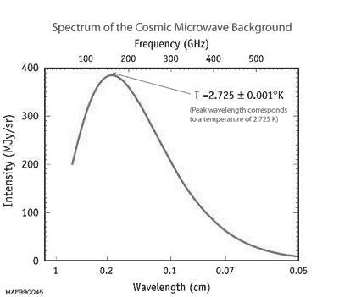

Credit: *NASA, WMAP*

This plot shows the black-body nature of the cosmic microwave background radiation. The spectrum corresponds to background radiation with a temperature of 2.725 K. These measurements were made by the FIRAS instrument on the COBE satellite. The error bars for each measurement are smaller than the width of the red line.

Over the last 15 years observations of this cosmic microwave background radiation (CMBR) from space-based missions such as [COBE](http://lambda.gsfc.nasa.gov/product/cobe/) and [WMAP](http://map.gsfc.nasa.gov/) and balloon-based missions such as [BOOMERanG](http://cmb.phys.cwru.edu/boomerang/) that operated in the Antarctic have provided a wealth of details. We can now view the slight fluctuations or anisotropies in the CMBR with unprecedented detail and compare observations with theory more thoroughly. The image below shows how the resolution of the CMBR has improved since its discovery in the 1960s. These slight fluctuations in the CMBR intensity are thought to provide information about slight variations in density in the early Universe.

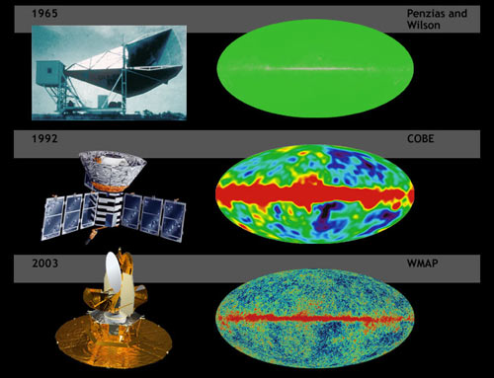

Credit: *NASA,*[*WMAP*](http://map.gsfc.nasa.gov/m_ig/ig_universe1.html)

Comparison of the level of detail of fluctuations in the CMBR from the 1960s through to the current WMAP mission.

1. **Ratios of primordial elements.** Astronomers are able to measure the relative amounts of the light nuclei hydrogen, deuterium (an isotope of hydrogen with one proton and one neutron), helium-3, helium-4 and lithium-7 in distant, unmixed clouds of primordial gas. The relative abundances of these nuclei correspond with the calculated predicted ratios from the Big Bang model.
2. **Observed evolution of extragalactic objects over cosmic time**. Evidence for this initially came from radio surveys which showed that the more distant (hence older) parts of the Universe appeared to contain stronger radio sources than the local region. Quasars, for instance, are not found in our local region but are far more common at redshifts of 2 or 3.   
   Recent observations by the Hubble Space Telescope and other telescopes have provided our deepest ever views of the Universe and clearly show evidence of galactic evolution and earlier stages in their formation.

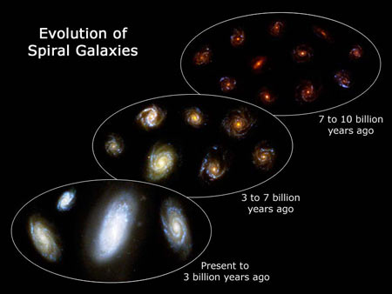

Credit: [*NASA*](http://www.nasa.gov/)*,*[*ESA*](http://spacetelescope.org/)*, F. Summers and Z. Levay (*[*STScI*](http://www.stsci.edu/)*)*

Recent observations by the HST show the evolution of spiral galaxies over time.

Formation of Matter

All matter, including the atoms in our bodies, the air we breathe and the gas in the Sun is composed is combinations of fundamental particles that were created during the Big Bang and subsequent evolution of the Universe. Before giving an outline of the key stages in the formation of matter we need to review the fundamental particles and forces in the Universe.

Fundamental particles, the building blocks of the Universe

Our current understanding of physics allows us to model events in the Universe nearly, but not quite back to the moment of the big bang. Significant developments in our understanding of the very early Universe are due to advances in high-energy [particle physics](http://particleadventure.org/particleadventure/) and particle accelerators such as those at [CERN](http://hands-on-cern.physto.se/). According to the "Standard Model" of particle physics we now know that all the matter around us is composed of combinations of only a few fundamental particles. These twelve particles fall into two families, *quarks* and *leptons*.

Quarks are the particles that group together to form *hadrons*. Hadrons made of three quarks in turn are called *baryons*. The most familiar baryons to us are the protons and neutrons that comprise the nuclei of the atoms in our bodies and the rest of the Universe. A proton comprises two *up* quarks and one *down* quark, whilst a neutron has two down quarks and only one up quark. If you study the following table, you will see that quarks have charges that are fractions of the charge of an electron, *e*. Hence the overall or net charge of a proton = 2 × (+2*e*/3) - 1 ×(-1*e*/3) = +1*e* and the overall charge of the neutron is 0.

Leptons include three charged particles, the *electron*, *muon* and *tau* particle. Each of these has an associated *neutrino* particle that is neutral.

Together these twelve particles are the building blocks of *matter*. Interestingly though, each of them has a corresponding *antiparticle*. These differ only in having the opposite charge but have the same mass as the corresponding matter particle. These antiparticles collectively are known as *antimatter*.

| **Family** | **Name** | **Charge** | **Rest Mass** | **Symbol** |
| --- | --- | --- | --- | --- |
| **Quarks** | up | +2*e*/3 | ~ 4 MeV | u |
| charm | ~ 1,250 MeV | c |
| top | ~1,784,000 MeV | t |
| down | -1*e*/3 | ~ 6 MeV | d |
| strange | ~ 110 MeV | s |
| bottom | ~ 4,100 MeV | b |
| **Leptons** | electron | -*e* | 0.511 MeV | e- |
| muon | 105.7 MeV | μ- |
| tau | 1784 MeV | τ- |
| electron neutrino | 0 | <2.5 eV | νe |
| muon neutrino | <170 keV | νμ |
| tau neutrino | <18 MeV | ντ |

The Fundamental Particles

Quarks can be grouped into three families, the up & down, the charm & strange and the top and bottom quarks. Each successive family has more massive particles. This trend is also followed by leptons; the electron and its neutrino are lighter than the muon and muon neutrino which in turn is lighter than the tau and tau neutrino.

Fundamental Forces

All interactions within the Universe arise due to only one of four fundamental forces:

The Fundamental Forces

| **Force** | **Example** | **Relative Strength (at 10-15m)** | **Range** | **Exchange Particle** |
| --- | --- | --- | --- | --- |
| **Gravitational** | Acts on all objects with mass. Responsible for orbit of Earth around Sun. Binds stars, planets and galaxies together. | 10-38 | Long range (infinite) | Described by general relativity as due to curvature of space-time.  Graviton is hypothesised exchange particle |
| **Weak** | Involved in transmutation of a neutron to a proton in Β- decay. | 10-13 | <10-18m | *W*+, *W*- and *Z*0 bosons |
| **Electromagnetic** | Interactions between charged particles. Responsible for light and chemical properties of matter and | 10-2 | Long range (theoretically infinite but limited due to cancelling effects of + and - charges and magnetic poles) | photon |
| **Strong** | Binds nucleons (protons and neutrons) together in nucleus | 1 | distance of adjacent nucleons in nucleus (10-15m) | gluons |

Immediately following the Big Bang all four forces are thought to have been combined and governed by one *Theory of Everything*. As the Universe expanded the energy density dropped and the forces started to split from each other. The first split occurred when gravity separated from the others at the *Planck time*, about 10-43 s. The Universe was at a temperature of 1032 K at this stage. Electromagnetism and the strong and weak nuclear forces were still combined as a *Grand Unified force*.

At 10-35s and a temperature of 1027 K the strong nuclear force separated from the electro-weak force. These two then separated at about 10-12s when the Universe was at 1015 K to give rise to the four distinct forces in our Universe today. Whilst gravity is the weakest of all these forces it now governs the evolution of the Universe due to its long-range influence and the amount of matter present.

Particle Production and Nucleosynthesis

The intense energy released in the Big Bang provided the source of all the matter in the Universe. Quantum physics explains the production of particle-antiparticle pairs. Whilst most of these went on to mutually annihilate each other, producing gamma photons, a very slight imbalance of matter over antimatter provided the building blocks for nuclei and atoms.

Within three minutes of the Big Bang, fusion reactions between protons and neutrons had made helium and deuterium nuclei. This process is called *nucleosynthesis*. 370,000 years later the Universe had expanded and cooled enough that the electrons could form stable atoms of hydrogen and helium. At this point matter is said to *decouple* from radiation and the Universe became transparent to photons. Light could thus travel long distances. We can view this event as the CMBR. The diagram below shows one of the possible nucleosynthesis sequences responsible for the production of helium-4 nuclei from protons and neutrons. About 24% of the baryonic mass of the early Universe was helium, the other 76% hydrogen.

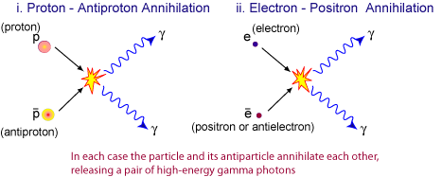

Credit: *CSIRO* Annihilation of particle-antiparticle pairs to produce gamma photons.

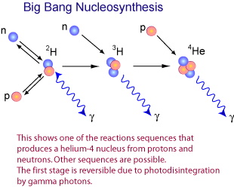

Credit: *CSIRO*

The production of helium via nucleosynthesis during the first three minutes of the Universe.

The table below provides an outline of the key events in the early history of the Universe.

The Big Bang model successfully accounts for the formation of the light elements, hydrogen, helium and traces of lithium and their isotopes from fundamental particles. Elements heavier than helium, including the iron, carbon and oxygen in our bodies and the uranium in the Earth were all synthesised later in stars. Our bodies are made of the debris of earlier generations of stars.

Modern Cosmology

Our understanding of the Universe has undergone profound changes due to recent observations and discoveries. For some time, astrophysicists have been aware that there is not enough visible matter in the Universe to account for the gravitational cohesion of clusters of galaxies or the rotation rate of spiral galaxies. These galaxies are spinning too fast for the observable matter in them to hold them together. To solve this dilemma the concept of *dark matter* has been suggested. This is matter that cannot be seen (hence *dark*) but otherwise interacts gravitationally with normal matter. A range of candidates from neutrinos, WIMPS (weakly-interacting massive particles) and MACHOS (massive astrophysical compact halo objects) have been proposed. Whilst some have now been ruled out there is still no consensus as to what dark matter is. The search continues.

Perhaps even more intriguing than the search for dark matter is the discovery, based on observations of distant supernovae, that the Universe is not just expanding but actually *accelerating*. Astrophysicists have proposed the concept of *dark energy* in the Universe. This acts as a repulsive force over the large scale, overcoming gravity. As with dark matter we do not yet know what this energy is in any detail.

These two discoveries combine to give us a very different picture of the Universe from that of a few decades ago. We now believe that all the "ordinary" matter that us, stars and galaxies are made of comprises only a small fraction of the constituents of the Universe.

Timeline since the Big Bang

| **Time since Big Bang** | **Temperature K** | **Era** | **Key Events** |
| --- | --- | --- | --- |
| 0 | ∞ | Radiation- dominated | Big Bang. Universe formed. Time before 10-43s is termed the Planck time. Our Physics cannot yet describe this interval in detail. |
| 10-43s | 1032 | Gravitational force separates from the strong-electro-weak force (Grand Unified force). Microscopic black holes form & disintegrate. |
| 10-35s | 1027 | Grand unification ends (the strong force separates from the electro-weak force). Quarks, leptons and antiparticles created. Inflation occurs? Universe expands by factor of 1025. Gravitons form and decouple. |
| 10-12s | 1015 | Four fundamental forces now distinct. Leptons separate into electrons, neutrinos and antiparticles. Gravity starts to control expansion. |
| 10-6 s | 1013 | Quarks & anti quarks form protons, neutrons & antiparticles. Protons & antiprotons; neutrons & antineutrons annihilate each other leaving slight excess of protons & neutrons plus lots of photons. |
| 1 s | 1010 | Neutrinos and antineutrinos decouple. |
| 15 s | 3 × 109 | Electrons and positrons annihilate each other. Slight excess of electrons left (= number of protons so net charge of Universe is 0) plus more photons. |
| 3 minutes | 109 | Protons and neutrons fuse into helium nuclei (nucleosynthesis). Spare neutrons used up. |
| 370,000 years | 3,000 | Matter- dominated | Matter decouples from radiation - electrons orbit nuclei to form atoms. Universe becomes transparent to photons as they can now travel long distances without interacting with charged particles. This decoupling is now viewed as the 2.7 K Cosmic Microwave Background Radiation. |
| 1 billion years |  | First stars and galaxies form. Heavy elements created in supernova explosions. |
| 8.4 billion years |  | Sun and solar system formed. |
| 13.4 billion years (NOW) | 3 | Humans on Earth |